**Module: CMPU 1031 Web Development 1 – TU856/1 and TU850/1**

**Week 1 – Lab 1**

**Lecturer: Fatmaelzahraa Eltaher**

Deadline: 24/09/2024 by 3.59 PM.

Dear Student,

Welcome to **Web Development 1**!

In this module, you are expected to develop a website over the semester. You will work with a team to deliver a website to a fictional client with your team.

**Task 1: Create a GitHub account (skip this if you already have a GitHub account)**

Over the semester, we will use GitHub, which allows you to store your code online, collaborate with others, and manage projects. To create a GitHub account:

Step 1: Open your web browser and go to [www.github.com](http://www.github.com/).

Step 2: On the GitHub homepage, click on **Sign up** button, usually located in the top-right corner of the page.

Step 3: Enter Your Details. Make sure you choose a unique username. This will be your identity on GitHub.

GitHub may ask you to solve a puzzle or verify your email to prove that you are not a robot. Once verified, GitHub will ask you some optional questions to customize your experience, like how many team members you have and what kind of projects you're working on. You can skip these if you prefer.

**Task 2: Select a client and Register your team**

To develop the website, you must work with a team. Each team has 3 (three) students.

Step 1: Form a team with two colleagues.

Step 2: Go to the module page on Brightspace and open the file **clients.pdf**. Together with your team, choose your favourite client. **Once you choose your client, you cannot change it later.**

Step 3: [Web-Development-Teams.xlsx](https://tudublin-my.sharepoint.com/:x:/g/personal/fatmaelzahraa_eltaher_tudublin_ie/EQqDPDd7DoxLmYo5lvx7-XQBTVZ2rawFr-0gl8itajq7Zw) and complete the form with the details asked (only one team member has to complete it). Ensure you insert each team member’s name, student number and GitHub username. The whole team should work on each assignment, but only one member needs to submit the files to Brightspace. Choose a member to be in charge of submitting the assignments.

**Task 3: Website Project Plan**

Go to Brightspace and download the file **CA1 – Website Project Plan**, where you will have a chance to talk about your plans for your website. Fill out the plan and submit it on Brightspace. To do that:

* Go to our module page on Brightspace, click on **Assessment** at the top menu, and select **Assignments**.
* Click on **CA 1 – Submission.** You will see the following screen.

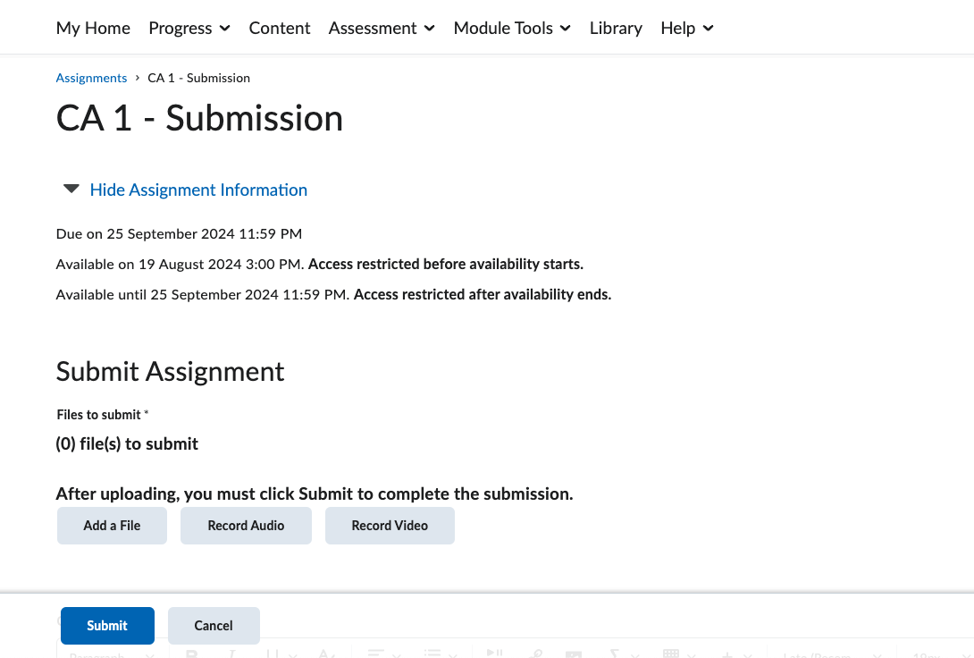

* Click on **Add a file** and then on **My computer**, then on **Upload** and find the file on your computer. Click on **Add**.
* Before clicking on **Submit**, scroll down until you see something similar to the screen below. On the box **Comments**, write an email to your client.

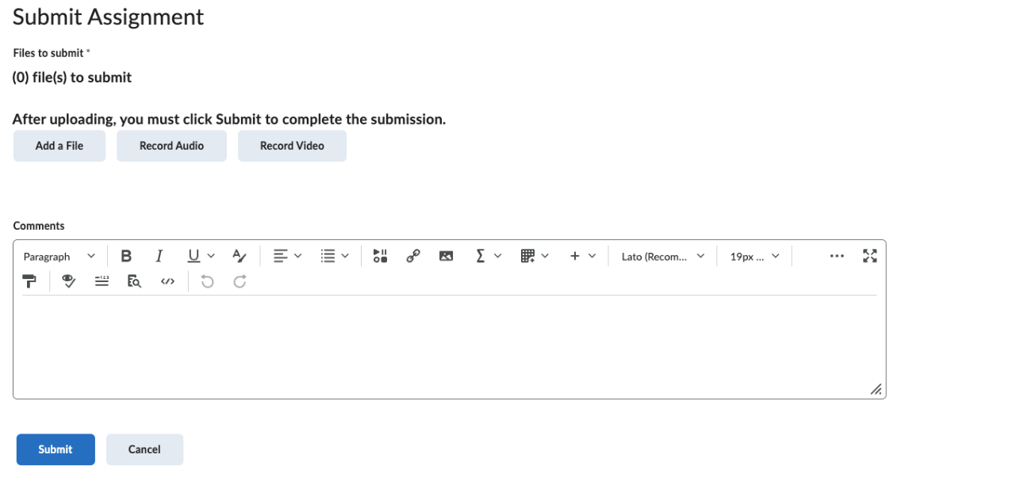

- Once you are done, click on **Submit**.